Operations/Work/Job Activity covered by this assessment: Cleaning Of HVOF Powder Feeder
Required Personal Protective Equipment (PPE) :

Safety glasses must be worn at times. |   Long and loose hair must be contained.
  Appropriate footwear with substantial uppers must be worn. |   Close fitting/protective clothing to cover arms and legs must be worn.
Respiratory protection devices required. |   Oil free leather gloves and spats must be worn.

Hearing protection must be used when using this machine.

Feeder Operation
- Remove Canister lid.
- Pour powder into clean Canister.
- Wipe Canister rim and replace lid.
- Turn POWER switch ON
- Place HEATER switch in ON position if powder needs drying. Drying period depends on powder composition, quantity, and moisture content. For wet powders, spread powder out in a Tray and place in oven at approximately 60-80°C for minimum30 mins or as long as needed.
- Adjust carrier gas pressure or flow at the gas source.
- Turn POWDER FEED switch ON. Adjust POWDER WHEEL SPEED SELECTOR dial to desired RPM.
- Execute spray run. When finished with spray run, put FEEDER ON/OFF switch in OFF position to stop powder feed.
- Shut off gas supply at the gas source to stop powder gas feed.
- Clean hopper if desired.

Basic Powder Feeder Cleaning
- Turn off unit and powder feeder gas supply.
- Wipe off exterior surfaces of powder feeder and cart.
- Check Canister pressure gauge. Remove Canister lid ONLY when all pressure has been relieved from Canister.
- Position powder receptacle to catch powder to be removed (see Figure). Powder Removal from Feeder.
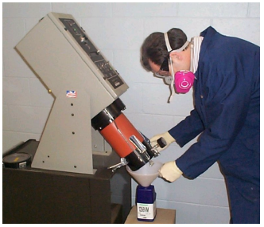

- Push down latch actuator on the back of the feeder (see Figure). Completely pivot feeder to empty powder from Canister.
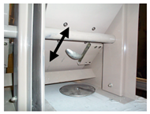

- Disconnect powder hose from gun. Disconnect carrier gas supply hose from powder feeder.
- For the HP/HVOF version with pinch valves, disconnect air/gas tube to the pinch valves from the feeder.
- Place CLEAN switch in ON position to rotate feed wheel at maximum RPM.
- Force clean, dry air into the gun end of the powder hose to purge hose of any powder.
- Direct air into canister to blow out powder.
- Clean powder feeder until no trace of powder is apparent.
- Place CLEAN switch in OFF position.
- Return feeder to its upright position. Make sure feeder latches back into position.
- Reconnect all hoses. Replace lid.

Thorough Powder Feeder Cleaning

- Turn unit and powder feeder supply gas off.
- Wipe exterior surfaces of powder feeder and cart.
- Check canister pressure gauge. Remove canister lid ONLY when all pressure has been relieved from canister.
- Position powder receptacle to catch powder to be removed (see Figure)


- Push down latch actuator on the back of the feeder (see Figure). Completely pivot feeder to empty powder from canister (see Figure).



- Disconnect powder hose from gun. Disconnect powder feeder gas supply hose from powder feeder.
- For the HP/HVOF version with pinch valves, disconnect air/gas tube to the pinch valves from the feeder.
- Place CLEAN switch in ON position to rotate feed wheel at maximum RPM.
- Force clean, dry air into the gun end of the powder hose to purge the hose of any powder.
- Direct air into canister to blow out powder.
- Clean powder feeder until no trace of powder is apparent
- Place CLEAN switch in OFF position. Gas Inlet Heater Blanket Connection Surface Ring Felt Ring
- Return feeder to its upright position. Make sure feeder latches back into position. PERSONAL INJURY HAZARD: Turn off the power and disconnect the power cable from the powder feeder before proceeding further.
- Disconnect heater blanket cable from powder feeder enclosure (see Figure).
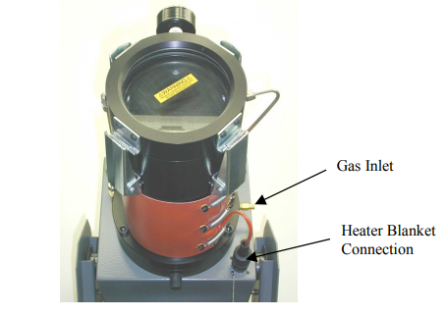

- Use a long handled standard screwdriver and unscrew the tamper assembly inside the canister and remove.
- Remove the carrier gas supply hose/tube from the canister.
- Loosen the pressure relief tube nut where it meets the powder feeder chassis. Then loosen the pressure balance tube nut where it meets the upper canister housing.
- Remove the three 3/8-16 x 1 inch socket head cap screws securing the upper housing assembly to the lower housing. Remove the powder canister upper housing assembly.
- Remove powder wheel motor shaft jam nut and washer.
- Carefully lift up the powder carrier wheel and remove. Do NOT pry powder carrier wheel with tool or distort the wheel.
- Lift out the felt rings, surface ring and soft rubber backup ring (see Figure 4-6). Use compressed air to blow powder off felt ring, wiper ring, and backup ring. Wipe clean the o-rings with isopropyl alcohol or a similarly o-ring compatible cleaning fluid to remove all powder residue.

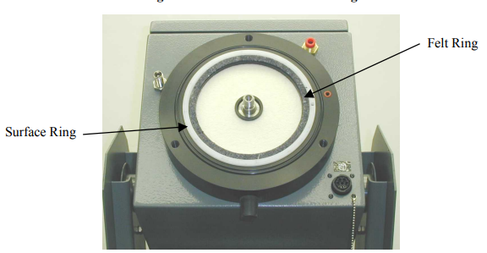

- Wipe clean the inside canister, surface ring, and powder wheel. Make sure not to lose the two O-rings by sealing the canister assembly to powder feeder enclosure. Clean these O-rings similar to above or replace if necessary.
- Occasionally, powder may bind the surface ring into its slot. Use compressed air around the edge of ring to remove powder. Rock the ring to free it from slot. If the ring consistently binds in the slot, reduce the PM Time Accumulator hours by half until the surface ring can move up and down within its slot. Wipe clean the surface ring with isopropyl alcohol or a similarly O-ring compatible cleaning fluid to remove all powder residue.
- Blow off the lower housing. Replace O-rings.
- Install new backup ring with the “dimple” side up, surface ring, and felt rings. Install new powder wheel, motor shaft jam washer and nut. Tighten nut.
- Replace surface ring if it is uneven or the edges start to wear. Inspect powder wheel on flat surface. Powder wheel must be flat. Bridges must be more than 75% intact from abrasion. Tighten nut with wrench and give wrench two short wraps in a clockwise direction to set tension on the nut.
- Replace canister with the upper housing. Tighten the three socket head cap screws.
- Reconnect the pressure balancing tube. To tighten and seal the pressure balancing tube properly, hold the bulkhead fitting with a wrench on the inside of the cabinet while tightening the nut on the outside.
- Reconnect nuts, hoses, and heater blanket plug.
- Reinstall the tamper assembly only hand tight. It will self-tighten with use.
- Replace lid.
- Reconnect the powder hose to the gun.
- Reconnect electrical power to the feeder.

